**Eddie Todd**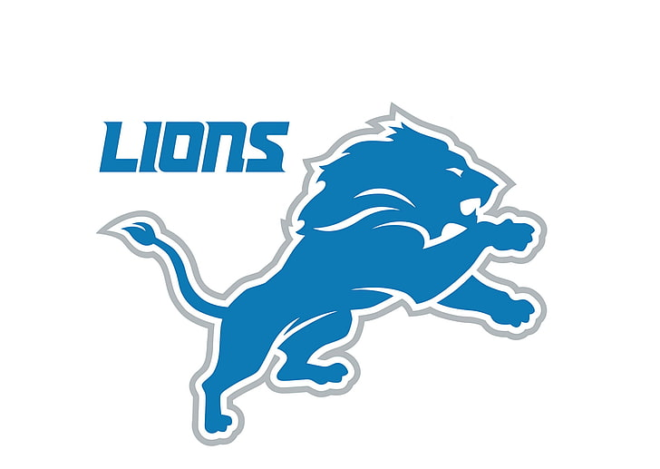

Detroit Lions Organization

11/6/2024

To the Board of Directors, Staff, and Detroit Lions Fans:

It is with immense pride and excitement that I humbly accept the position to lead the Detroit Lions organization. As we look forward to the future, I am eager to build upon the hard work that has brought us to this moment. I am committed to fostering a culture of determination, integrity, and relentless pursuit of success—both on and off the field.

The Lions' history is rich, and together we will continue to shape a future that brings pride not only to our team but to the city of Detroit and the entire Lions fanbase. The road ahead is filled with promise, and I look forward to working alongside the incredible talent, coaches, staff, and supporters that make this organization truly special.

Thank you for entrusting me with this incredible opportunity. I look forward to bringing my passion and leadership to this team as we strive toward greatness.

**One Pride,**

Eddie Todd

Head Football Coach

Detroit Lions